January 15, 2025

Kenneth Spencer

Benton County Treasurer

620 Market St

PO Box 630

Prosser, WA 99350

RE: 2025 Tax Year Property Tax Certification

Dear Kenneth,

This is to confirm that 2025 tax year property taxes were certified to you

via PACS certification process on January 15, 2025.

The total Real and Personal Taxes (excluding omitted property tax and

late penalty tax for personal property) is:

$ 318,402,817

The attached worksheet shows a breakdown of the various taxing districts

within Benton County. Tax dollars are rounded to the nearest dollar for this report.

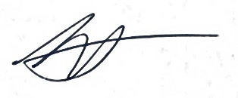Sincerely,

Bill Spencer

Benton County Assessor

Cc: Benton County Board of County Commissioners

Benton County Auditor